# 0.4 Check Feature Variances

[('drug_HBA', 'Not Applicable (Non-numeric)'),
('drug_HBD', 'Not Applicable (Non-numeric)'),
('drug_logP', 'Not Applicable (Non-numeric)'),
('drug_TPSA', 'Not Applicable (Non-numeric)'),
('drug_Dielectric', 0.05116844473282817),
('drug_δD', 0.037048165722233205),
('drug_δP', 0.008204438083816323),
('drug_δH', 0.6122883110168309),
('Solvent1_HBA', 'Not Applicable (Non-numeric)'),
('Solvent1_HBD', 'Not Applicable (Non-numeric)'),
('Solvent1_frac', 0.08845099271205835),
('Solvent1_logP', 'Not Applicable (Non-numeric)'),
('Solvent1_TPSA', 'Not Applicable (Non-numeric)'),
('Solvent1_Dielectric', 209.67126964213907),
('Solvent1_δD', 1.344129503269101),
('Solvent1_δP', 24.036071999535622),
('Solvent1_δH', 41.25729256241237),
('Solvent2_frac', 0.06811262949037754),
('Solvent2_HBA', 'Not Applicable (Non-numeric)'),
('Solvent2_HBD', 'Not Applicable (Non-numeric)'),
('Solvent2_logP', 'Not Applicable (Non-numeric)'),
('Solvent2_TPSA', 'Not Applicable (Non-numeric)'),
('Solvent2_Dielectric', 844.2780130648069),
('Solvent2_δD', 0.09479882845691663),
('Solvent2_δP', 24.018780530721155),
('Solvent2_δH', 172.09150793103686),
('Solvent1_Solvent2_Ra', 139.2580350595279),
('ILR_coordinate', 1.0291453485700837),
('weighted_HBA', 0.25644682686662196),
('weighted_HBD', 0.09851336913049018),
('weighted_logP', 0.29352749846825354),
('weighted_TPSA', 31.46447800853578),
('weighted_Dielectric', 634.9335914355269)]

features with small variances (1e-05):
[]

# 0.5 Correlation Analysis Between Features and Target
Correlation with Target Variable ('value'):
value 1.000000
weighted_logP 0.800675
weighted_HBA 0.767912
ILR_coordinate 0.669573
Solvent1_frac 0.488742
weighted_HBD 0.469875
Temperature, K 0.126170
Solvent2_δD 0.081065
Solvent1_δD -0.047065
drug_δH -0.125937
drug_Dielectric -0.126144
drug_δD -0.126151
drug_δP -0.126151
Solvent1_δP -0.141411
Solvent1_Dielectric -0.425882
Solvent1_Solvent2_Ra -0.433548
Solvent2_δP -0.455894
Solvent2_δH -0.470666
Solvent2_frac -0.488742
Solvent2_Dielectric -0.504084
Solvent1_δH -0.543192
weighted_TPSA -0.730849
weighted_Dielectric -0.822935
drug_HBA NaN
drug_HBD NaN
drug_logP NaN
drug_TPSA NaN
Name: value, dtype: float64

Correlation with Target Variable ('value'):
value 1.000000
weighted_logP 0.800675
weighted_HBA 0.767912
ILR_coordinate 0.669573
weighted_HBD 0.469875
Temperature, K 0.126170
Solvent2_δD 0.081065
Solvent1_δD -0.047065
drug_δH -0.125937
drug_Dielectric -0.126144
drug_δD -0.126151
drug_δP -0.126151
Solvent1_δP -0.141411
Solvent1_Dielectric -0.425882
Solvent1_Solvent2_Ra -0.433548
Solvent2_δP -0.455894
Solvent2_δH -0.470666
Solvent2_Dielectric -0.504084
Solvent1_δH -0.543192
weighted_TPSA -0.730849
weighted_Dielectric -0.822935
Name: value, dtype: float64

Stratified Splitting of Test & Training Datasets - Develop Stratas for Solvent Systems
Unique Solvent Systems and their counts:
 | Solvent System | Count
0 | Ethanol - Water | 90
1 | 2-Propanol - Water | 90
2 | 2-Propanol - Tetrahydrofuran | 90
3 | Acetonitrile - Water | 90
4 | 2-Propanol - Ethyl Acetate | 90
5 | 2-Propanol - Acetone | 90
6 | 1,4-Dioxane - Water | 81
7 | Ethanol | 10
8 | 2-Propanol | 10
9 | Acetonitrile | 10
10 | Water | 10
11 | 1,4-Dioxane | 9

Develop Flutamide Solubility Bins and Their Solubility Ranges
Distribution of samples per solubility bin:
solubility_bins
0 223
1 224
2 223
Name: count, dtype: int64

Solubility Range for Each Bin:
Bin 0: [-3.4316, 0.9413)
Bin 1: [0.9413, 1.6473)
Bin 2: [1.6473, 1.9039)

Develop Composite Strata Based on Solvent Systems and Flutamide Solubility
Distribution of samples per composite stratification key:
 | count
composite_strat_key
1,4-Dioxane - Water_Sol Bin0 | 45
1,4-Dioxane - Water_Sol Bin1 | 33
1,4-Dioxane - Water_Sol Bin2 | 3
1,4-Dioxane_Sol Bin1 | 4
1,4-Dioxane_Sol Bin2 | 5
2-Propanol - Acetone_Sol Bin1 | 18
2-Propanol - Acetone_Sol Bin2 | 72
2-Propanol - Ethyl Acetate_Sol Bin1 | 38
2-Propanol - Ethyl Acetate_Sol Bin2 | 52
2-Propanol - Tetrahydrofuran_Sol Bin1 | 18
2-Propanol - Tetrahydrofuran_Sol Bin2 | 72
2-Propanol - Water_Sol Bin0 | 58
2-Propanol - Water_Sol Bin1 | 32
2-Propanol_Sol Bin1 | 8
2-Propanol_Sol Bin2 | 2
Acetonitrile - Water_Sol Bin0 | 48
Acetonitrile - Water_Sol Bin1 | 34
Acetonitrile - Water_Sol Bin2 | 8
Acetonitrile_Sol Bin1 | 3
Acetonitrile_Sol Bin2 | 7
Ethanol - Water_Sol Bin0 | 62
Ethanol - Water_Sol Bin1 | 28
Ethanol_Sol Bin1 | 8
Ethanol_Sol Bin2 | 2
Water_Sol Bin0 | 10
dtype: int64

Minimum samples in any composite bin: 2. This should be sufficient for stratification.

0.7 Develop Baseline Model
Linear Regressor Baseline - Training Metrics:
MAE: 0.2448
MSE: 0.1083
RMSE: 0.3291
R2: 0.9228

Linear Regressor Baseline - Test Metrics:
MAE: 0.2530
MSE: 0.1171
RMSE: 0.3422
R2: 0.9055

1.1 Stratified Splitting Based on Solvent System Keys - Random Forest Regression
Random Forest Regressor - Training Metrics:
MAE: 0.0142
MSE: 0.0005
RMSE: 0.0219
R2: 0.9996

Random Forest Regressor - Test Metrics:
MAE: 0.0364
MSE: 0.0029
RMSE: 0.0538
R2: 0.9981

1.2 Stratified Splitting Based on Solvent System Keys - XGBoost Regression
XGBoost Regressor - Training Metrics:
MAE: 0.0075
MSE: 0.0001
RMSE: 0.0098
R2: 0.9999

XGBoost Regressor - Test Metrics:
MAE: 0.0345
MSE: 0.0026
RMSE: 0.0512
R2: 0.9983

2.1 Stratified Splitting Based on Solubility Bins - Random Forest Regression
Random Forest Regressor - Training Metrics:
MAE: 0.0140
MSE: 0.0005
RMSE: 0.0218
R2: 0.9997

Random Forest Regressor - Test Metrics:
MAE: 0.0388
MSE: 0.0035
RMSE: 0.0590
R2: 0.9975

2.2 Stratified Splitting Based on Solubility Bins - XGBoost Regression

XGBoost Regressor - Training Metrics:
MAE: 0.0075
MSE: 0.0001
RMSE: 0.0100
R2: 0.9999

XGBoost Regressor - Test Metrics:
MAE: 0.0316
MSE: 0.0021
RMSE: 0.0457
R2: 0.9985

3.1 Stratified Splitting Based on Composite Strata - Random Forest Regression

--- Random Forest Regressor (Composite Stratification) ---
Random Forest Regressor - Training Metrics:
MAE: 0.0128
MSE: 0.0004
RMSE: 0.0198
R2: 0.9997

Random Forest Regressor - Test Metrics:
MAE: 0.0352
MSE: 0.0032
RMSE: 0.0569
R2: 0.9974

3.2 Stratified Splitting Based on Composite Strata - XGBoost Regression
--- XGBoost Regressor ( Composite Stratification) ---
XGBoost Regressor - Training Metrics:
MAE: 0.0077
MSE: 0.0001
RMSE: 0.0100
R2: 0.9999

XGBoost Regressor - Test Metrics:
MAE: 0.0279
MSE: 0.0018
RMSE: 0.0419
R2: 0.9986

4.1 Hyperparameter Tunning by Randomized Search CV - XGBoost Model
Starting RandomizedSearchCV for XGBoost...
Fitting 5 folds for each of 30 candidates, totalling 150 fits
RandomizedSearchCV finished.

Best parameters found for XGBoost:
regressor__subsample: 1.0
regressor__n_estimators: 200
regressor__max_depth: 3
regressor__learning_rate: 0.2
regressor__colsample_bytree: 1.0
Best Mean Absolute Error (MAE) from CV for XGBoost: 0.1242

Performance of the best XGBoost model on the full dataset:
MAE: 0.0080
RMSE: 0.0111
R2: 0.9999

4.2 Hyperparameter Tunning by Randomized Search CV - Random Forest Model
Starting RandomizedSearchCV for Random Forest...
Fitting 5 folds for each of 30 candidates, totalling 150 fits
RandomizedSearchCV for Random Forest finished.

Best parameters found for Random Forest:
regressor__n_estimators: 100
regressor__min_samples_split: 2
regressor__min_samples_leaf: 1
regressor__max_features: 1.0
regressor__max_depth: 30
Best Mean Absolute Error (MAE) from CV for Random Forest: 0.1782

Performance of the best Random Forest model on the full dataset:
MAE: 0.0111
RMSE: 0.0170
R2: 0.9998

5.1 SHAP Analysis - XGBoost Model

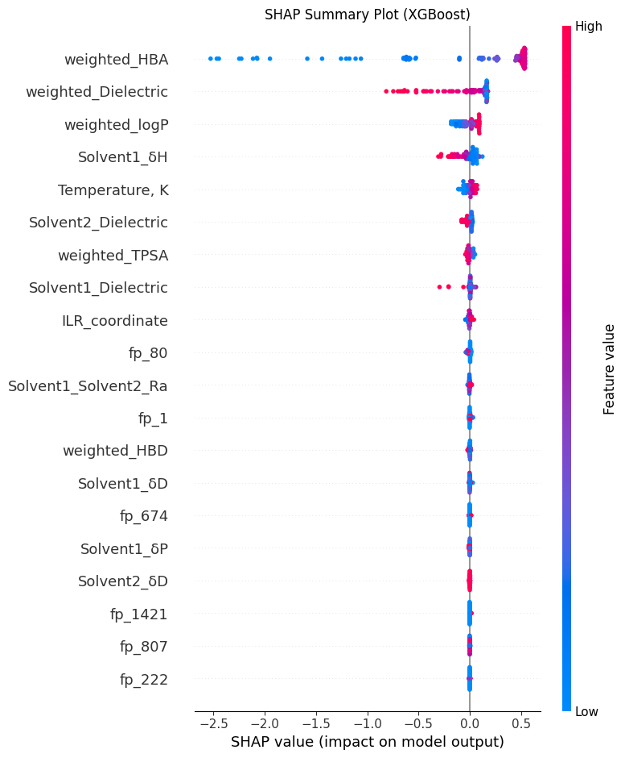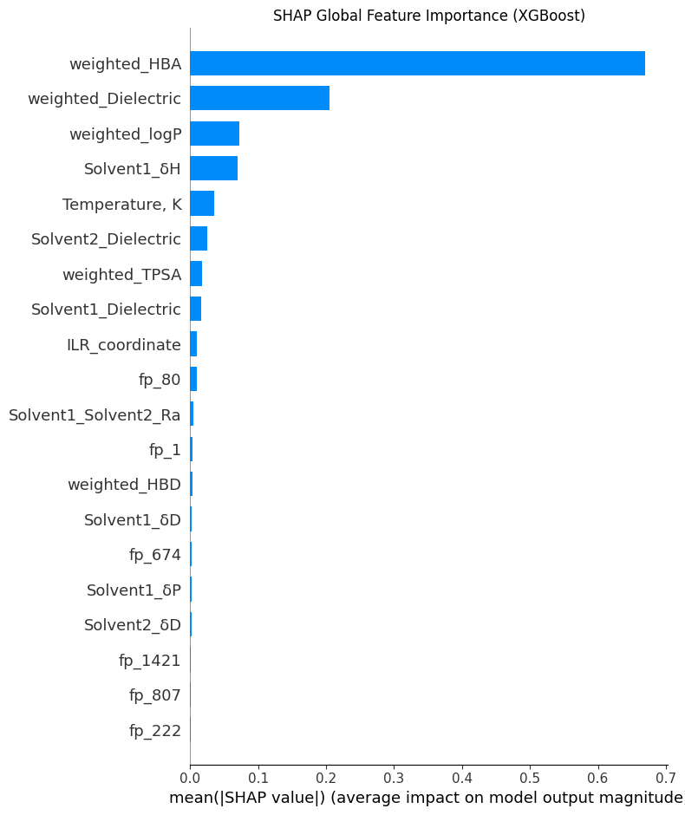

5.2 SHAP Analysis - Random Forest Model
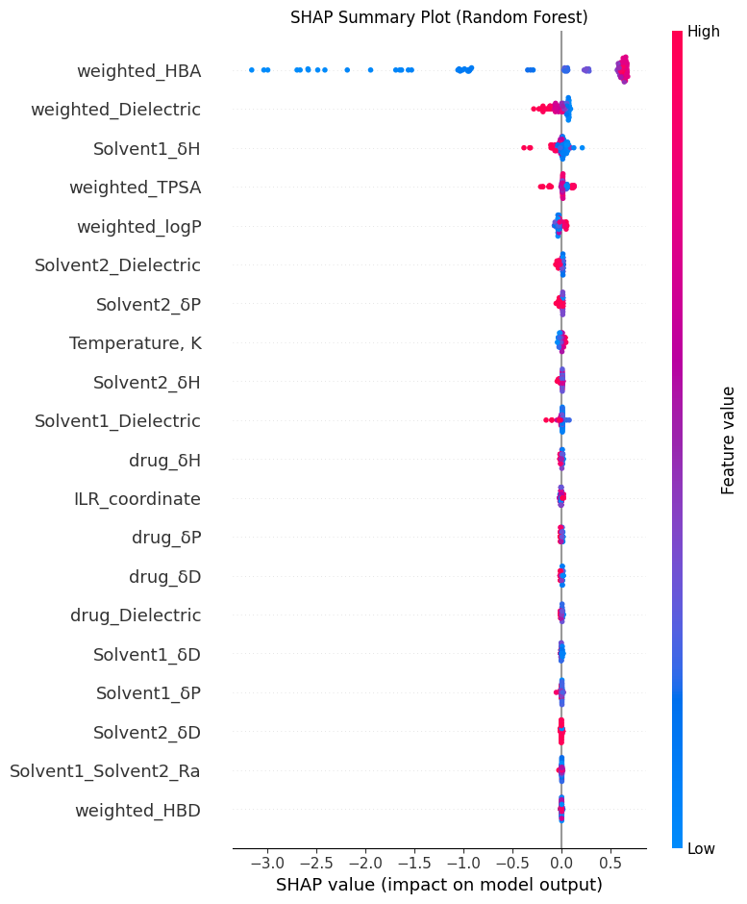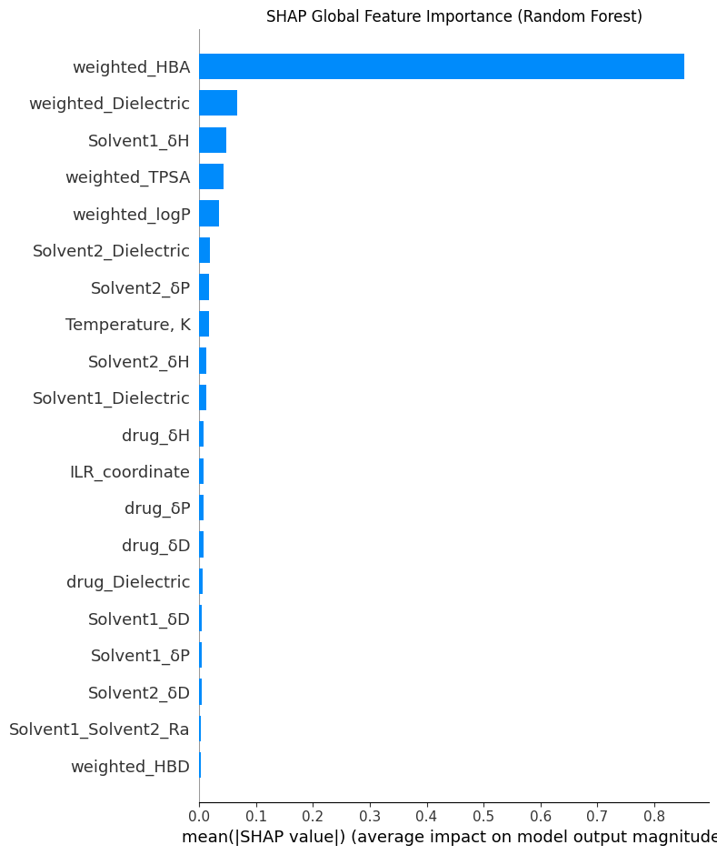

6.1 Confidence Intervals (CI) Calculation for Tuned Random Forest and XGBoost Models
====================================
Confidence Intervals (95%) for XGBoost Model Metrics:
====================================

XGBoost Regressor (from RandomizedSearchCV best estimator):
Test MAE: 0.1242 (95% CI: 0.0693 - 0.1792)
Test RMSE: 0.2135 (95% CI: 0.0708 - 0.3562)
Test R2: 0.9336 (95% CI: 0.8738 - 0.9935)

====================================
Confidence Intervals (95%) for Random Forest Model Metrics:
====================================

Random Forest Regressor (from RandomizedSearchCV best estimator):
Test MAE: 0.1782 (95% CI: 0.1137 - 0.2428)
Test RMSE: 0.2660 (95% CI: 0.1499 - 0.3821)
Test R2: 0.8622 (95% CI: 0.6637 - 1.0606)

7.1 Display Full CI Results
====================================
Full 95% Confidence Interval Results for Tuned Models:
====================================

XGBoost Regressor (Tuned with RandomizedSearchCV):
Test MAE: 0.1242 (95% CI: 0.0693 - 0.1792)
Test RMSE: 0.2135 (95% CI: 0.0708 - 0.3562)
Test R2: 0.9336 (95% CI: 0.9983 - 0.9989)

Random Forest Regressor (Tuned with RandomizedSearchCV):
Test MAE: 0.1782 (95% CI: 0.1137 - 0.2428)
Test RMSE: 0.2660 (95% CI: 0.1499 - 0.3821)
Test R2: 0.8622 (95% CI: 0.6637 - 1.0606)

Metric | XGBoost Mean | XGBoost 95% CI | Random Forest Mean | Random Forest 95% CI |
|:----------|---------------:|:------------------|---------------------:|:-----------------------|
| Test MAE | 0.1242 | [0.0693 - 0.1792] | 0.1782 | [0.1137 - 0.2428] |
| Test RMSE | 0.2135 | [0.0708 - 0.3562] | 0.2660 | [0.1499 - 0.3821] |
| Test R2 | 0.9336 | [0.8738 - 0.9935] | 0.8622 | [0.6637 - 1.0606] |

